Ideation Phase
Brainstorm & Idea Prioritization Template
Date | 25 January 2026
Team ID | LTVIP2026TMIDS26598
Project Name | Prevent User Deletion If Assigned To An Incident
Maximum Marks | 4 Marks

Step-1: Team Gathering, Collaboration and Select the Problem Statement

The project titled “Prevent User Deletion If Assigned to Incident in ServiceNow” began with the formation of our project team. Our team members came together with a shared interest in understanding IT Service Management (ITSM) processes and implementing automation using the ServiceNow platform.During our initial meetings, we discussed various real-time challenges faced by organizations while managing users and incidents in ServiceNow. We identified that accidental deletion of users assigned to active incidents could lead to workflow disruption, data inconsistency, and loss of accountability.
Through collaborative discussions and analysis of system behavior, we evaluated multiple problem areas related to user management and record dependencies. After careful consideration, we collectively decided to focus on developing a Business Rule-based validation system to prevent deletion of users linked to incidents.
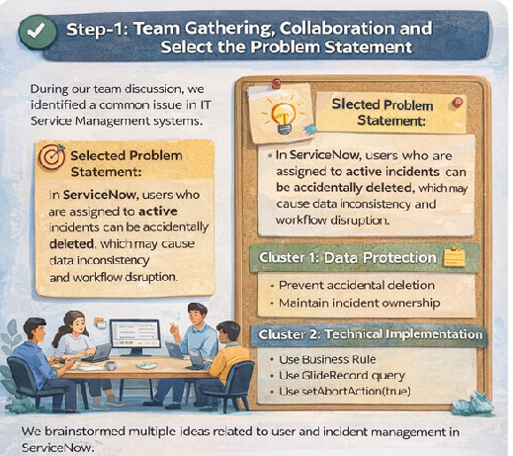

Step-2: Brainstorm, Idea Listing and Grouping

After finalizing our problem statement, we moved to the next phase — Idea Listing and Grouping. In this stage, our team conducted brainstorming sessions to generate and organize different ideas related to user and incident management in ServiceNow.
We listed several potential solutions such as checking incident assignments before deletion, implementing server-side validation using Business Rules, displaying system error messages, and ensuring referential integrity between tables.
These ideas were then grouped into three main categories:
- Data Protection Ideas – Prevent accidental deletion and maintain incident ownership.
- Technical Implementation Ideas – Use Before Delete Business Rule, GlideRecord queries, and setAbortAction().
- System Integrity Ideas – Maintain workflow continuity and improve administrative governance.
This structured grouping helped us clearly identify the most practical and scalable solution for our project.

Step-3: Idea Prioritization

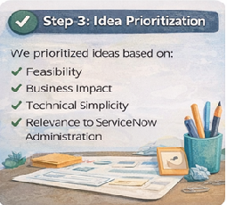
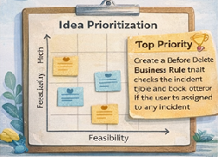

Submitted Template link: https://app.mural.co/t/da9640/m/da9640/1750069641517/0f044a20c64822d02c0f812d34 60c24477a5a6fa?sender=u47cabad28f7fc43c7e754820
Conclusion: Building Blocks of secure service management.
Like configuring system safeguards in a ServiceNow environment, our team carefully structured ideas to prevent accidental deletion of users assigned to incidents.
Through structured brainstorming and collaboration, we grouped ideas into meaningful clusters focused on data protection, technical implementation, and system integrity.
The highest-priority solution — implementing a Before Delete Business Rule on the sys_user table — ensures that:
✔ Users assigned to incidents cannot be deleted
✔ Data consistency is maintained
✔ Workflow integrity is preserved
✔ IT service processes remain uninterrupted

